\\\\\\\\\\\\\\\\\\\\\\\\\\\\\\\\\\\\\\\\\\\\\\\\\\\\\\\\\\\\\\\\\\\\\\\\\\\\\\\\\\\\\\\\\\\\\\\\\\\\\\\\\\\\\\\\\\\\\\\

SaniBook

**Shaping Kenya’s Sanitation Future First Edition:**

Unlocking Kenya's Potential: Shared Knowledge, Collective Action

With SaniBook



First Edition

SANIBOOK



SaniBook is the revolutionary platform that unlocks synergy and maximizes impact by transforming fragmented data into unified action.

***SaniBook: Experience the Paradigm Shift that is Changing Sanitation Landscape***

Sanitation Revolutionized: The Definitive Path to National Excellence

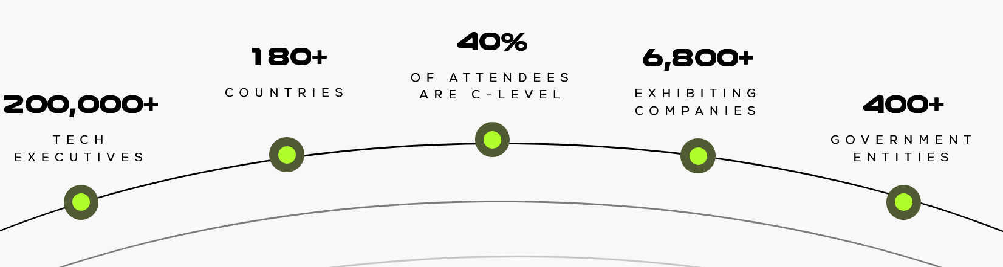

Only 57% safely managed sanitation. The technology exists, but the system is broken. Tell us about your scalable blueprint for everyone else to know."

Stop seeing a crisis. Start seeing the $70+ Billion-Shilling Market:

Over 80% of Kenyans lack access to sanitation due to Conceptual Myopia and social behaviors. How are you rewriting the code to shift this paradigm? Share your story

**$324 Million.** **Annual economic penalty** for poor sanitation.

What has been your contribution? Share your story

Sanitation data gaps are the foundation of Kenya's 'invisible crisis': Without a unified system , policymakers are flying blind, turning billions in investment into guesswork and fatally obstructing accountability. Tell us about your intervention

60% of Kenya's sanitation investment bleeds away in institutional chaos. we need Unified Authorities—a single, accountable pipeline that cuts through the fragmentation and delivers SDG 6.2: What has been your Voice

60% of Kenya's sanitation investment bleeds away in institutional chaos. we need Unified Authorities—a single, accountable pipeline that cuts through the fragmentation and delivers SDG 6.2: What has been your Voice

Estimated $4.4 billion sanitation funding gap, two thirds of citizens on unsafe sanitation, costing the economy 0.9% of its GDP annually in lost health and productivity. What has been your impact?

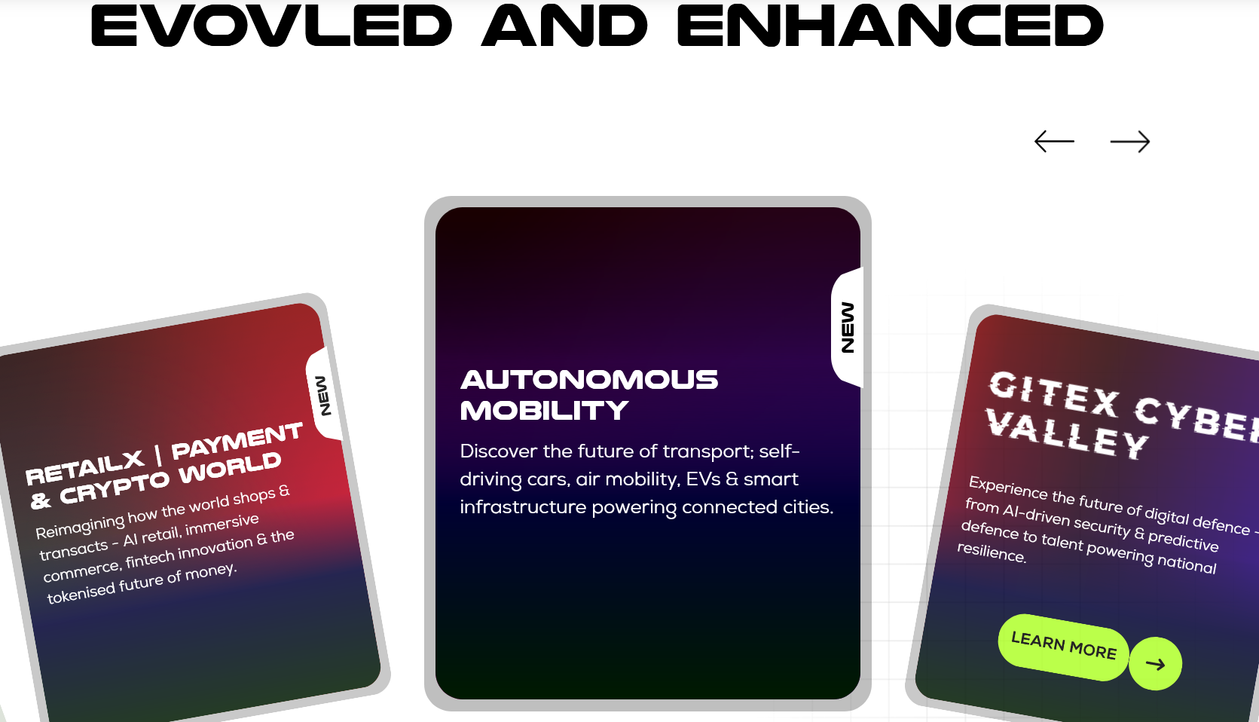



**You are the Missing Piece! Join the Movement and Write Your Chapter**

You Should Not Just Do, Write the Blueprint for Kenya's Healthiest Future.

***Pioneering Voices who Stepped Up to Lead***

Include the Logos for KEWASNET, APSA, IDIA, KWAHO





**Cross-Sector Alliance**

**Accelerating the next wave of sanitation excellence**

**Sanitation Awards, Mapping Actors, Market place for Technologies and innovations, Pro-poor Voices , Coordination Civil Society, Private sector Interveners, Policy directors,**



**.** 

**Sponsor Sanibook:**

**Don't just follow the conversation—** **future-proof your impact and** **own the revolution**